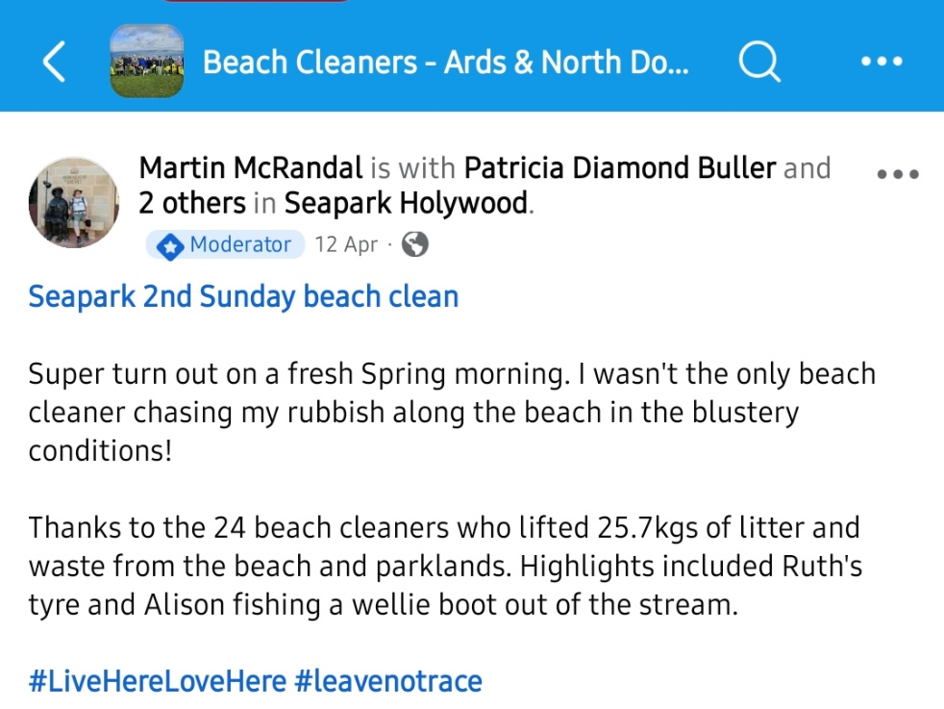
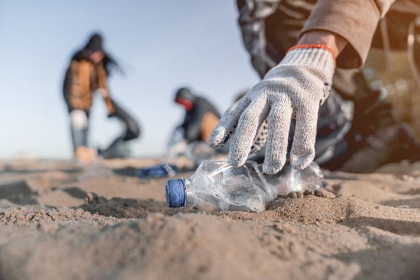
Where?
How much collected?
Who attended?
Who Organised it?
The Goal:
Conserve and sustainably use the oceans, seas and marine resources for sustainable development

The Idea:
A data driven system used to track, organise and report on beach cleanups in NI. The system will be used to support the volunteer group “Beach Cleaners – Ards & North Down” who run many events in the North Down area with support from local councillors.

Why?
The cleaning of beaches reduces marine litter and the amount of microplastics in the oceans which are key marine pollution contributors. A fully implemented system will allow for a well targeted approach to ensure a wide array of beaches will be cleaned.

For Who?
The system should be designed for use from:
- Organisers of the beach clean events
- Volunteers

Data Source:
Here is a screenshot of a Beach Cleaners – Ards & North Down Facebook post. This presents the current way that they are reporting on their important work. Though not a fully-fledged data source, it gives insight into what their needed data to store would be.

Goal 14
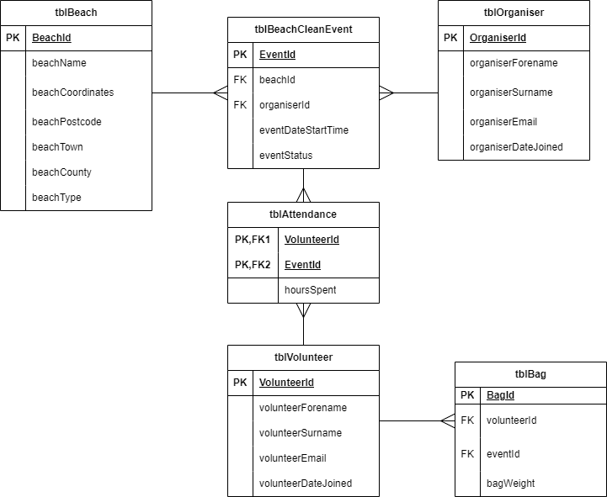
Data Integrity:
- Attendance table is included to remove many-to-many relationship of Beach Clean Event to Volunteer
- Checks will be needed for valid emails, postcodes and coordinates
- Enumerations can be used for event status
- All user input data will need to be checked to prevent SQL injection attacks

Questions that can be Answered:
- Who has attended an event
- How much was collected at an event
- What beaches haven’ t been cleaned recently
- What beaches have never been cleaned
- How much each volunteer has collected
- Expected amount of rubbish to be collected at an event (average of each member going)
Initial ERD:

